 | 26.9.1 Editors - Properties Editor - Modifiers Properties Tab - Add Modifier menus
Table of content
Add Modifier menu buttons 1
Add Modifier Button 1
Add Asset Modifier 1
Add Modifier menu 2
Type to Search… 3
Add Asset Modifier menu 3
Search… 3
Type to Search… 3
Geometry Nodes 3
Geometry Nodes Assets 4
Data Browser 4
Edit box 4
Add Fake User 4
User 5
Add 5
Remove 5
Custom Inputs and Outputs 5
Unassigned (Catalogue) 5

Add Modifier menu buttons

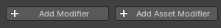
There are two types of modifiers, builtin modifiers and geometry nodes modifiers that were marked as assets.

Add Modifier Button
The button to the left adds built in modifiers to all selected objects.

Note: When adding modifier assets will apply to all selected object.

Add Asset Modifier
The button to the right adds geometry nodes assets as modifiers to all selected objects.

Note: When adding modifier assets will apply to all selected object.

Add Modifier menu
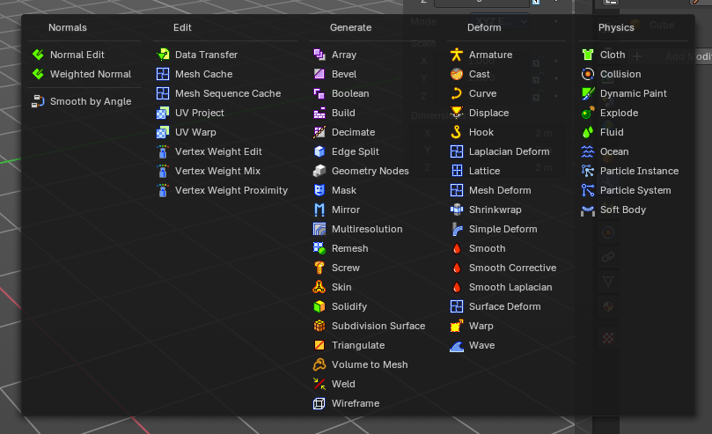
This menu with a list of modifier items adds built in modifiers to all selected objects. This shows with all objects.
These are divided into four categories:
- Normals
- Edit
- Generate
- Deform
- Physics

Select any entry to add the modifier.

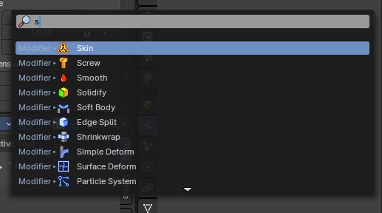
Type to Search…
When the menu is open, you can press any key to start typing to search, this will filter the modifiers by name.

Add Asset Modifier menu
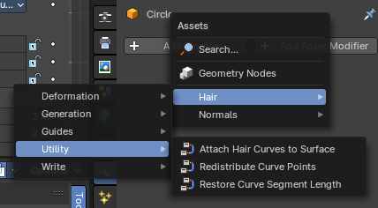
There is also an add asset modifier menu items that shows all Geometry Node groups marked as assets that you can add as a modifier to all selected objects.

Search…
Search for a specific modifier.

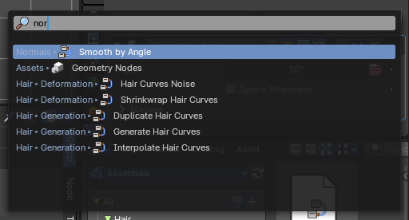
Type to Search…
When the menu is open, you can press any key to start typing to search, this will filter the asset modifiers by name.

Geometry Nodes
Add a geometry nodes modifier.
This is usually done in the Geometry Nodes Editor.

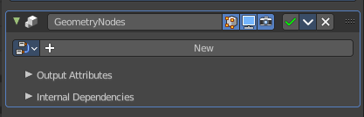
The geometry Nodes modifier adds a geometry node tree, which can be modified in the geometry node editor.

Manage the nodes. If there is no geometry node tree for the current object, then you will see the New button.

Geometry Nodes Assets
These are Geometry Node groups that have been marked as assets, set as a “Modifier” in the node group properties, and organized into an Asset Browser category.

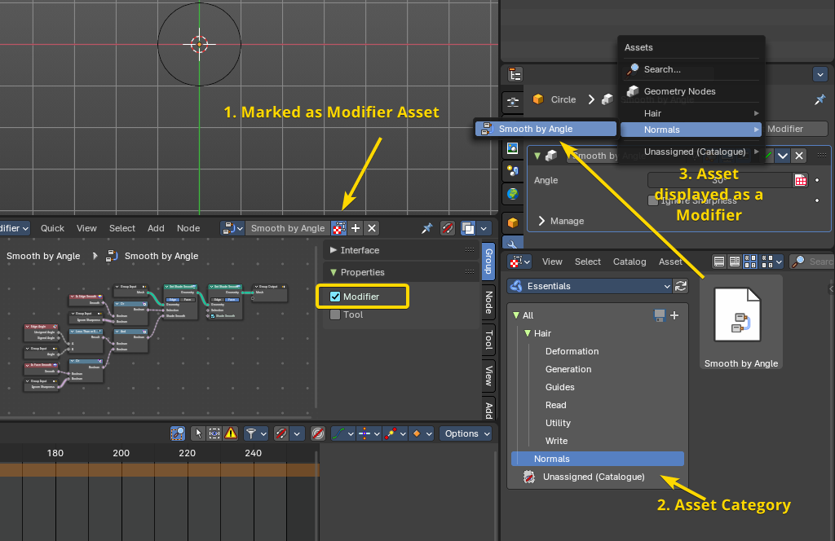
1 . Mark Node Group as asset and set the Node Group properties to “Modifier”, so this will show in the Modifier stack. Do this from the Geometry Nodes editor.
2. Assign the Nodegroup to a category in the File Browser Editor.
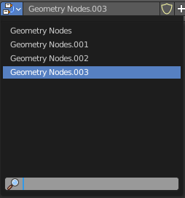
3. Now you can use the Add Asset Modifier menu to quickly assign a new Geometry Nodes Asset Modifer preset to any object.

Data Browser
The list of available geometry node trees in the scene.

Edit box
The name of the current active geometry node tree. Here you can also rename the node tree.

Add Fake User
Wit this button you assign a fake user to this selected geometry node tree.
Data, like node trees, that is not longer linked to anything else gets removed when you save and reload a scene. Bforartists has the concept of fake users to go around this behavior. An image with a fake user is in fact linked to something. And so it is not lost when you save and reload the scene.

User
The number of users that uses this data. Data with a user number of 0 will be removed with closing Bforartists.

Add
Adds a duplicate geometry nodes nodegroup.

Remove
Removes the geometry node tree. To delete it completely you need to purge it. See Fake user.

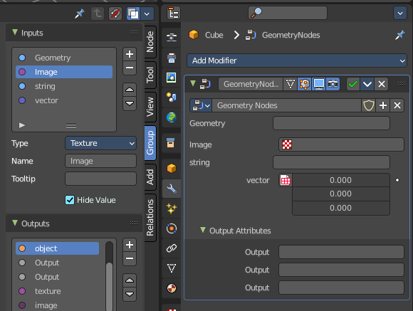
Custom Inputs and Outputs
In case you define custom inputs and outputs in the geometry nodes editor, then these inputs and outputs also shows in the modifier.

Unassigned (Catalogue)
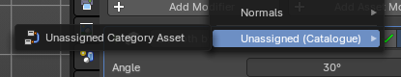
Custom modifier assets. This menu item shows when you for example add a geometry node, and apply it. Then this applied node tree goes into this menu which allows you to reuse it. The term non-assets is a label, and no custom asset.

